INSTRUCTIONS TO UPDATE CONCIERGE PLATFORM FROM R1.1 TO R1.2

STEP 1
Scan the below barcodes on the Concierge scanner only if you are updating Concierge platform from 1.1.3.0 or an earlier build to 1.1.4.x or later that supports the DataWedge feature
NOTE: Scan these barcodes before upgrading the Concierge platform (MDZ) otherwise you will see an exception ‘Datawedge has stopped working’
Scan the barcodes while powering up the Concierge. Note: No beep will be heard upon scanning programming barcodes so to be sure they scanned correctly move the barcode within the scanner’s field of view for a few seconds by varying the distance to the scanner.
1.
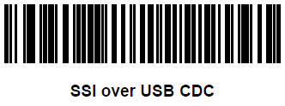

2.
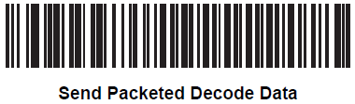

STEP 2
Apply platform release 1.2 - REL_1.2.0.4_ota.mdz by following the instructions below:
Copy the file to the root folder of a USB flash drive (note: there must be only one .MDZ file in the root folder)
- Boot device
- Login into the Admin mode
  - Long-press in the lower-right-hand corner (on the ‘M’ icon) until the PIN code entry box comes up
  - Enter the Admin PIN code (default is 5678)
- Touch the clock display in the lower right-hand corner
- Select Settings
- Select About device and read the Build number
  - If the first portion of the Build number reads 01.1.0.x or higher, select System Update and proceed to Step 9.
  - Otherwise, continue on to Step 6.
- Touch the clock display in the lower right-hand corner
- Select the Application Configuration menu option
- Select the System Update App
- Connect USB drive or SD card containing MDZ update package (there must be only one .MDZ file and it must be in the root folder of the USB/SD card)
- Click the “Apply” button. . If you see ‘No Storage media found’ go Back to Settings > Storage, scroll down to USB STORAGE and click on Mount SD card. Go back to System Update and click Apply.
- Wait for the MDZ to apply fully. The device will reboot itself.

STEP 3
Download and apply the Scanner firmware upgrade MDZ similarly

