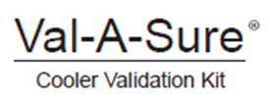

Cooler Validation Log Sheet
For documenting blood product transport cooler validation procedures.

Cooler ID | SOP Reference | Date of Validation Pass | Date of Validation Fail | Corrective Action Taken (if any) | Reviewed by  (full name) | Date for  Re-Validation

